Name: Astha Arpit Bhatt

Enrollment: 196140316006

**Practical – 3**

Built an applet that displays a horizontal rectangle in its centre. Let the rectangle fill with colour from UP to Down.

import java.awt.Graphics;

import java.awt.event.*;

import java.awt.*;

import java.applet.*;

public class pra3 extends Applet

{

public void paint(Graphics g)

{

int width=50;

int height=10;

g.setColor(Color.red);

g.drawRect(150,100,50,200);

for(int i=1;i<21;i++)

{

try

{

Thread.sleep(1000);

}

catch(InterruptedException e)

{

}

g.fillRect(150,100,width,height);

height = height +10;

}

}

}

/*

<applet code="pra3.class" width=600 height=400>

</applet>

*/

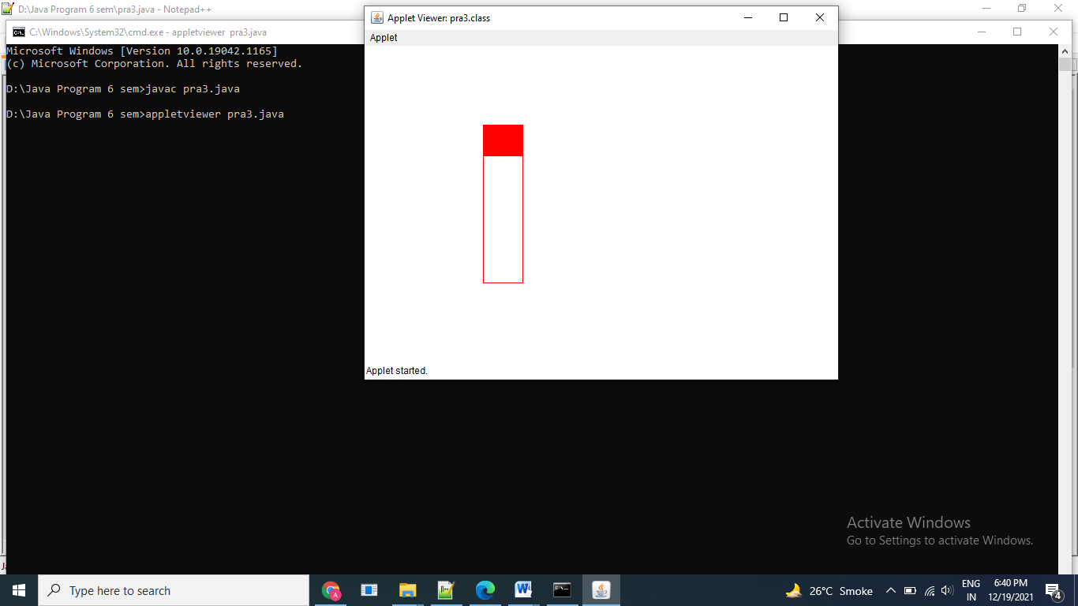

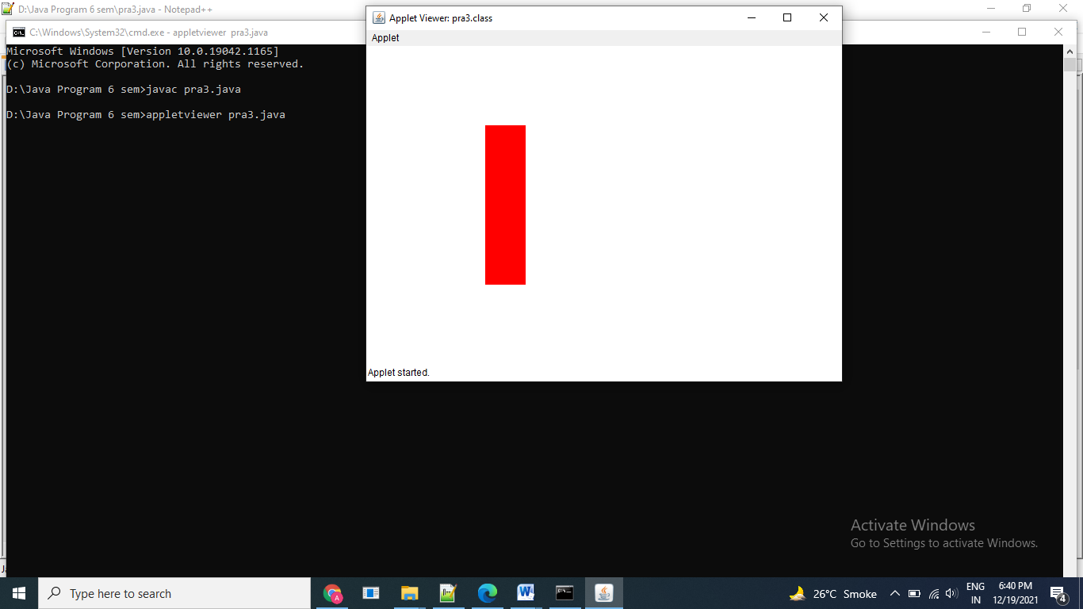

Exercise:

1. Draw the following in applet window.

import java.awt.Graphics;

import java.awt.event.*;

import java.awt.*;

import java.applet.*;

public class pr3e1 extends Applet

{

public void paint(Graphics g)

{

g.setColor(Color.RED);

g.drawOval(145,100,150,140);

g.setColor(Color.MAGENTA);

g.drawOval(175,100,90,140);

g.setColor(Color.YELLOW);

g.drawOval(205,100,30,140);

}

}

/*

<applet code="pr3e1.class" width=600 height=400>

</applet>

*/

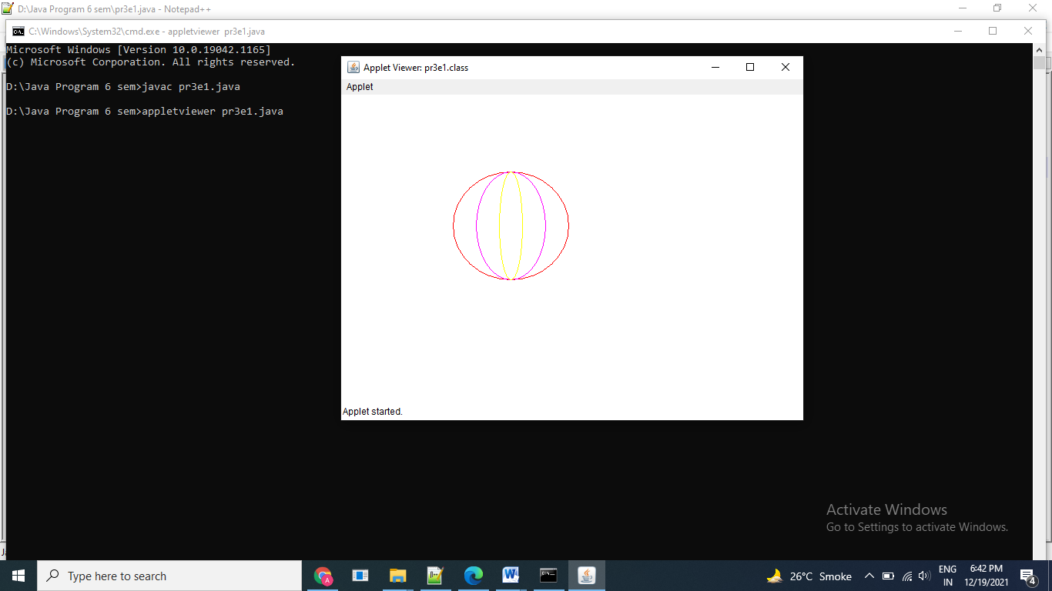

1. Draw an oval that fills up eventually with pink colour

import java.awt.Graphics;

import java.awt.event.*;

import java.awt.*;

import java.applet.*;

public class pra3e2 extends Applet

{

public void paint(Graphics g)

{

g.drawOval(20,20,200,120);

g.setColor(Color.pink);

g.fillOval(20,20,200,120);

}

}

/*

<applet code="pra3e2.class" width=600 height=400>

</applet>

*/

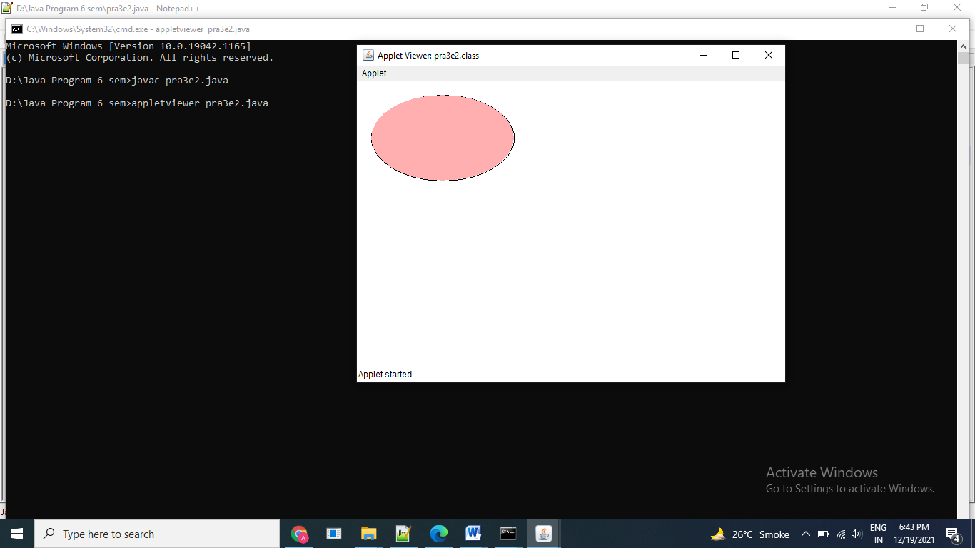

Thanks mam!!!